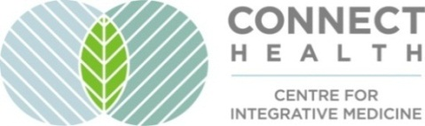

Special Program offer: Creating a Happier Life
“Amazing Things happen when you introduce your body to your Mind”
Connect Heart Body Mind towards Coherence

A Connect Health Workshop

What is stopping you from experiencing the joy of being alive today?

To help you discover your unique answers we are offering a program of 4 individualized 50-minute sessions that will be available in 2026.

Chew-Nyet Lee and Keet Neville are Master Therapeutic Counsellors in mind-body medicine. We will introduce science-based approaches along with ancient practices to your self-discovery program. Appling neuroplasticity, nervous system regulation and drawing from our own experiences, we will help you create your unique path and action items.

Two 50 minutes sessions with Chew-Nyet include:
-The Hakomi Method to aid in understanding your challenges or Body Logic to connect to your body and unique wisdom;
-Experiential exercises to help discover unconscious obstacles that could be blocking you.

Two 50 minutes sessions with Keet include:
- learning basic Heart Math tools to help develop Heart/Brain ‘coherence’ and increase emotional regulation;
- Counselling and mindfulness as a way to instill these practices into everyday life.

Book Online or in person appointments at Connect Health. For an effective outcome, completing all 4 sessions within two months is ideal. Program Fee: $560 + GST;

TO BOOK: Email us at chewnyetl@gmail.com or call 778.988.9349 to schedule and complete your booking.

